**Stating the Problem**

Calculating how much you would weight on other planets.

**Input / Output Description**

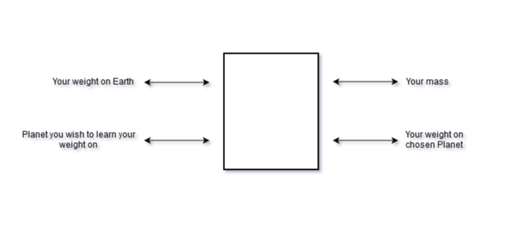

**Hand Example**

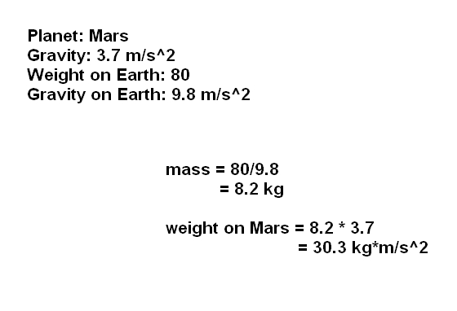

**Flowchart**

**C:\Users\Win7\Desktop\Flowchart.png**

**Algorithm Development**

1. Declare constants of gravities on planets.

2. Acquire a weight on Earth from the user.

3. Convert the weight into mass. (weight / gravity on Earth)

4. Print the mass of given weight.

5. Acquire a planet from the user.

6. Compute the weight on chosen planet. (mass * g of chosen planet)

7. Print the new weight.